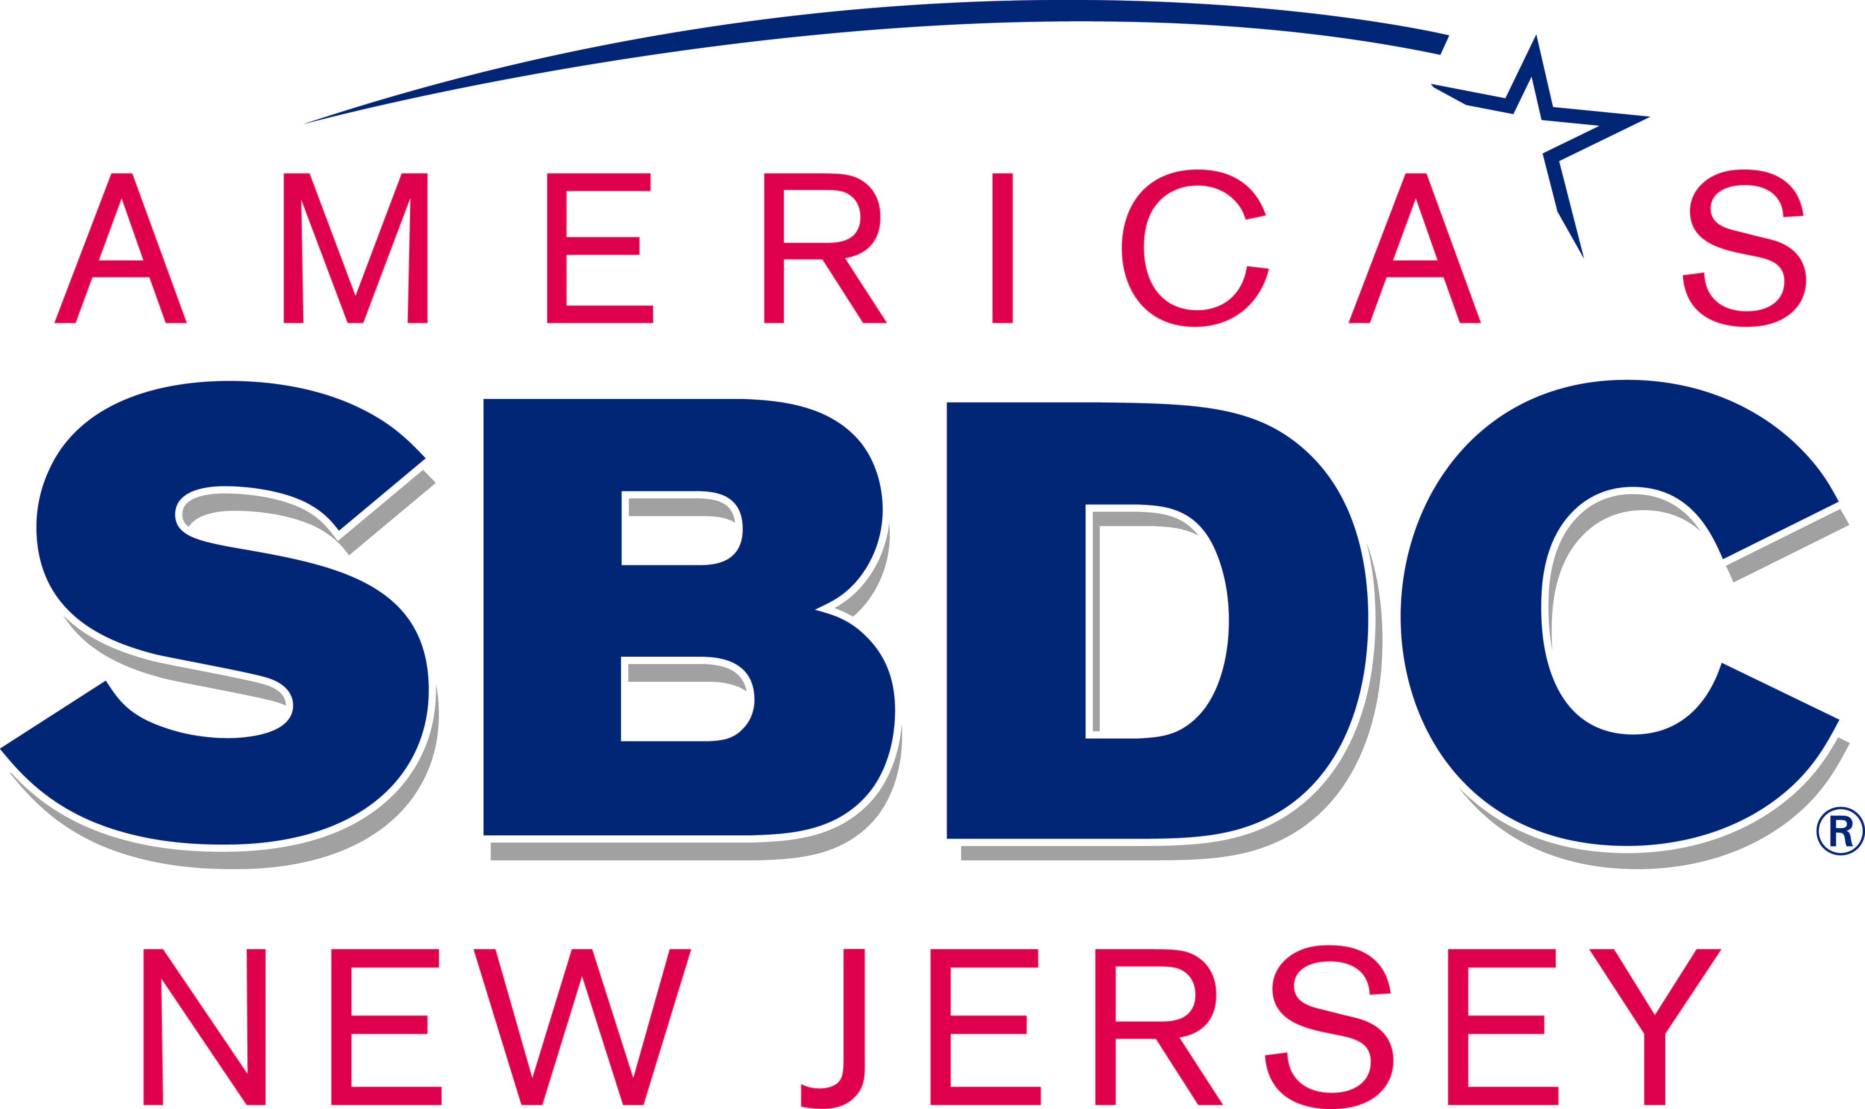

**NJ Small Business Development Center**



**Spring 2014**

**Training Schedule**

**Small Business Information & Resources**

**Providing management consulting and affordable training to small businesses in Burlington, Camden, Gloucester and Salem Counties,**

**since 1986.**



856-225-6221

www.rsbdc.org



NJ

Small Business Development Center

Rutgers School of Business Camden| Camden



*Accounting & QuickBooks Certificate*

**Accounting Fundamentals $120 (2 sessions)**

(Saturdays Feb. 15 & 22, 2014) 9am-noon

This course is designed to provide students with a fundamental knowledge of accounting and record keeping procedures and is the first course in the “Accounting/QuickBooks Certificate Program.” Students will learn concepts needed for bookkeeping and become knowledgeable with accounting terminology used to operate financial software.

(2 sessions; 6 total hours.)

**QuickBooks Basic $120 (2 sessions)**

(Saturdays Mar. 8 & 15, 2014) 9am-noon

This introductory course explains how QuickBooks can simplify the accounting process for a small business. Using QuickBooks students will learn 1) how to set up a company; 2) how to record business transactions; 3) understand QuickBooks reports; and 4) the components of financial statements.

(6 total hours.)

**QuickBooks Advanced $150 (3 sessions)**

(Saturdays Mar. 29, Apr. 5 & 12, 2014) 9am-noon

This intermediate course is designed to put the student in a simulated real business environment managing both the Customers/Sales and Vendors/Expenses capabilities in QuickBooks.

(3 sessions; 9 total hours.)

*\*\*Discounts available for multiple registrations\*\**

**Perfect for Small Business Owners, Accounting Students and Book**

**Keepers**



Funded in part through a Cooperative Agreement with the U.S. Small Business Administration, The New Jersey Small Business

Development Centers (NJSBDC) network is also funded by the state of New Jersey and is hosted by Rutgers Business School: Newark and New Brunswick.

NJSBDC network is an accredited member of the Association of Small Business Development Centers

**419 Cooper Street, Camden, NJ 08102 856-225-6221**

TABLE OF CONTENTS

TRAINING POLICIES & LOCATIONS 1 - 2

DESCRIPTIONS AND SCHEDULE OF SPRING 2014 PROGRAMS

LISTED BY TITLE 6 – 12

Courses are offered by: the New Jersey Small Business Development Center, Rutgers University - Camden through a network of community colleges and county offices (these include, but are not limited to, the library system and economic development agencies) in our four county service area, of Burlington, Camden, Gloucester and Salem counties.

Basic Entrepreneurial Skills Certificate Series 3

Advanced Certificate Series 3

TRAINING CERTIFICATE APPLICATION 5

GENERAL INFORMATION 16 - 22

FUNDING PARTNERS 23

**CONSULTING:** Have you ever thought you might like the independence of owning your own business? Experts are available to discuss pros/cons and options. The following sources provide individualized, confidential, one - to - one consulting at no charge.

**Appointments are necessary** and are conducted by qualified local experts.

* **New Jersey Small Business Development Center at Rutgers - Camden (RSBDC) For** information on counseling locations and times or to schedule an appointment call: **856 - 225 - 6221** Monday through Friday, 8:30 - 4:30.

**Rutgers, The State University of New Jersey, 419 Cooper Street, Camden, NJ 08102**

* **SCORE – Counselors to America’s Small Business: To schedule an appointment Monday through Thursday call: 856 – 406-1532.**

[Graphics Solutions • Where Vision Becomes
                  Reality!](http://www.graphics-solution.com/)

Printing done by:

**P 856-579-7469   F 856-579-8096**

Westview Professional Campus • 335 Glassboro Road, Suite 202A  
                          Woodbury Heights, NJ 08097  
**Consider us for all your Printed Products, Apparel and Signage Needs!**

Welcome to the NJ Small Business Development Center at Rutgers – Camden

The NJ Small Business Development Center at Rutgers -Camden (RSBDC) is part of a statewide network of service providers that offer counseling and AFFORDABLE training to entrepreneurs in the State of New Jersey.

The RSBDC has been in existence for over 30 years and has helped thousands of individuals start and build successful businesses. If you are just starting up, need financing, business/marketing planning assistance or help bringing your business to the next level the RSBDC can help. The award winning experienced consultants at the RSBDC provide training & counseling in Burlington, Camden, Gloucester and Salem Counties.

# Locations of programs throughout South Jersey

**REGISTRATION**: To register, contact the number listed in the following pages for each class.

**CLASS SIZE: For FEE** classes must have a **minimum of five (5) participants** in order to run. **Free** classes must have a **minimum of ten (10) participants to run.** Please **REGISTER EARLY** to ensure the class runs. With most of our instructor(s) we are required to give a five - day notice if the class is going to run. To avoid the chance of cancellation, please register as soon as possible. If registered you will be contacted regarding any changes in the program offering.

**CANCELLATIONS**: The New Jersey Small Business Development Center - reserves the right to cancel any class for which registration is insufficient. In the event that we must cancel a program, you will be notified by telephone. Please be sure that we have a working telephone number and a backup number. Unless you are notified to the contrary, your registration has been accepted and you should report to the seminar as scheduled.

**EMERGENCY CLOSINGS:** If you have any question regarding a class cancellation due to weather or lack of enrollment, please call the location directly.

**PLEASE NOTE:** All course and event listings are accurate as of date of publication. Some information may be subject to change. Please check our website for any updates [www.rsbdc.org](http://www.rsbdc.org) or call 856 - 225 - 6221.

**PRICING POLICY FOR FEE - BASED CLASSES**

* Registration required.
* No reservations are accepted without payment.
* In case of cancellation, either a credit will be given or, if requested a refund check will be issued within six to eight weeks.
* Refund/credit of registration fee **will be granted only if notified 48 hours in advance of the start of the class. After that *NO REFUNDS WILL BE GIVEN.***
* If you cancel your registration with 48 hours’ notice and choose to register for a future course, your credit will be valid for use within 12 months of the originally scheduled program.
* Credit Cards are the preferred method of payment (Master Card, Visa & Discover accepted.)
* Cash Payments will be accepted at our office, during business hours only.
* **Checks & Money Orders should be made out to Rutgers University.* *Exception: For Burlington County College or Gloucester County College courses, the check will be made out to those institutions.**

**TRAINING LOCATIONS**

|  |
| --- |
| **BURLINGTON COUNTY** |

Burlington County Library – Main Branch

5 Pioneer Blvd.

Westampton, NJ 08060

609 - 267 - 9660

Burlington County College Training Center

1000 Briggs Road, Suite 120

Mt. Laurel, NJ 08054

856 - 222 - 9311

Fort Dix, Department of the Army

US Army Garrison,

Ft Dix, NJ 08064

609 - 562 - 2186

Willingboro Public Library

@ The Willingboro Town Center

Rt. 130 and Levitt Parkway

Willingboro, NJ 08046

609 - 267-9660

|  |
| --- |
| CAMDEN COUNTY |

NJSBDC – Rutgers University, Camden

419 Cooper Street

Camden, NJ 08102

856 - 225 - 6221

Latin American Economic Development

Association, Inc. (LAEDA)

433 Market St., Suite L100

Camden, NJ 08102

856 - 338 - 1177 ext 1177

Waterfront Technology Center

200 Federal Street

Camden, NJ 08103

856 - 479 - 9010

|  |
| --- |
| GLOUCESTER & SALEM COUNTIES |

Gloucester County Library - Main Branch

389 Wolfert Station

Mullica Hill, NJ 08062

856 - 223 - 6025



Gloucester County College Continuing Ed.

1492 Tanyard Road

Sewell, NJ 08080

856 - 415 - 2216 or 2217

Please check our website for any additions or changes to the schedule.  
[www.rsbdc.org](http://www.rsbdc.org)

**Certificate Programs:**

***Basic Entrepreneurial Skills Certificate Series:***

**Starting a Business from A–Z — 6 Hours**

**Writing a Business Plan — 6 Hours**

**Successfully Marketing Your Small Business — 3 Hours**

***Advanced Entrepreneurial Certificate Program***

Presented by:

Burlington County College

and

Gloucester County College

in conjunction with

The NJ Small Business Development Center

In the Spring 2014 Semester we will be offering the advanced certificate program at Burlington

County College and Gloucester County College. This program is a 30 - hour program that   
covers a wide variety of topics on starting a small business. This program will build on our   
existing certificate program and includes Recording Business Transactions, Understanding   
Financial Statements and Business Ownership: Contracts and Agreements, and Marketing   
Research & Strategies.

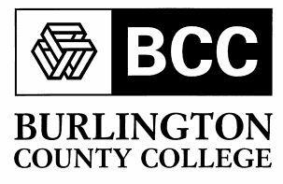

This program is designed to give an entrepreneur or a prospective entrepreneur the tools and understanding needed to successfully start and run a new business. Completion of the following courses is required in order to qualify for this certification.

**Starting a Business from A–Z — 6 Hours**

**Recording Business Transactions — 3 Hours**

**Financing a Small Business — 3 Hours**

**Marketing Research & Strategies for Business Success — 6 Hours**

**Writing a Business Plan — 6 Hours**

**Understanding Financial Statements — 3 Hours**

**Business Ownership: Contracts and Agreements — 3 Hours**

##### BURLINGTON COUNTY COLLEGE CERTIFICATE PROGRAM

|  |  |  |  |  |  |  |
| --- | --- | --- | --- | --- | --- | --- |
| **Date** | **Title** | **Day** | **Time** | **Fee** | **Phone** | **City** |
| 02/26/14 03/05/14 | Starting a Business from A - Z  (2 Parts) | Wednesday Wednesday | 6 - 9 pm | $ 115 | 609-894-9311 ext 3027 | Mt. Laurel |
| 03/12/14 03/26/14 | Writing a Business Plan  (2 Parts) | Wednesday Wednesday | 6 - 9 pm | $ 115 | 609-894-9311 ext 3027 | Mt. Laurel |
| 05/21/14 05/28/14 | Starting a Business from A - Z  (Parts 1 & 2) | Wednesday Wednesday | 6 – 9 pm | $ 115 | 609-894-9311 ext 3027 | Mt. Laurel |
| 06/04/13 06/11/14 | Writing a Business Plan  (Parts 1 & 2) | Wednesday Wednesday | 6 – 9 pm | $ 115 | 609-894-9311 ext 3027 | Mt. Laurel |
| 04/02/14 | Financing a Business | Wednesday | 6 - 9 pm | $ 60 | 609-894-9311 ext 3027 | Mt. Laurel |
| 04/09/14 | Recording Business Transactions | Wednesday | 6 - 9 pm | $ 60 | 609-894-9311 ext 3027 | Mt. Laurel |
| 04/16/14 04/23/14 | Marketing Research and Strategies  (2 Parts) | Wednesday Wednesday | 6 - 9 pm | $ 115 | 609-894-9311 ext 3027 | Mt. Laurel |
| 04/30/14 | Understanding Financial Statements | Wednesday | 6 - 9 pm | $ 60 | 609-894-9311 ext 3027 | Mt. Laurel |
| 05/07/14 | Business Ownership, Contracts and Agreements | Wednesday | 6 - 9 pm | $ 60 | 609-894-9311 ext 3027 | Mt. Laurel |

##### GLOUCESTER COUNTY COLLEGE CERTIFICATE PROGRAM

|  |  |  |  |  |  |  |
| --- | --- | --- | --- | --- | --- | --- |
| **Date** | **Title** | **Day** | **Time** | **Fee** | **Phone** | **City** |
| 01/30/14 02/06/14 | Starting a Business from A – Z (2 Parts) | Thursday Thursday | 6 - 9 pm | $ 115 | 856-415-2216 | Sewell |
| 02/13/14 02/20/14 | Writing a Business Plan  (2 Parts) | Thursday Thursday | 6 - 9 pm | $ 115 | 856-415-2216 | Sewell |
| 02/27/14 | Successfully Marketing Your Small Business | Thursday | 6 - 9 pm | $ 60 | 856-415-2216 | Sewell |
| 03/06/14 03/20/14 | Starting a Business from A – Z (2 Parts) | Thursday Thursday | 6 - 9 pm | $ 115 | 856-415-2216 | Sewell |
| 03/27/14 04/03/14 | Writing a Business Plan (2 Parts) | Thursday Thursday | 6 - 9 pm | $ 115 | 856-415-2216 | Sewell |
| 04/10/14 | Financing A Business | Thursday | 6 - 9 pm | $ 60 | 856-415-2216 | Sewell |
| 04/17/14 | Recording Business Transactions | Thursday | 6 - 9 pm | $ 60 | 856-415-2216 | Sewell |
| 04/24/14 05/01/14 | Marketing Research and Strategies  (2 parts) | Thursday Thursday | 6 - 9 pm | $ 115 | 856-415-2216 | Sewell |
| 05/08/14 | Understanding Financial Statements | Thursday | 6 - 9 pm | $ 60 | 856-415-2216 | Sewell |
| 05/15/14 | Business Ownership, Contracts and Agreements | Thursday | 6 - 9 pm | $ 60 | 856-415-2216 | Sewell |

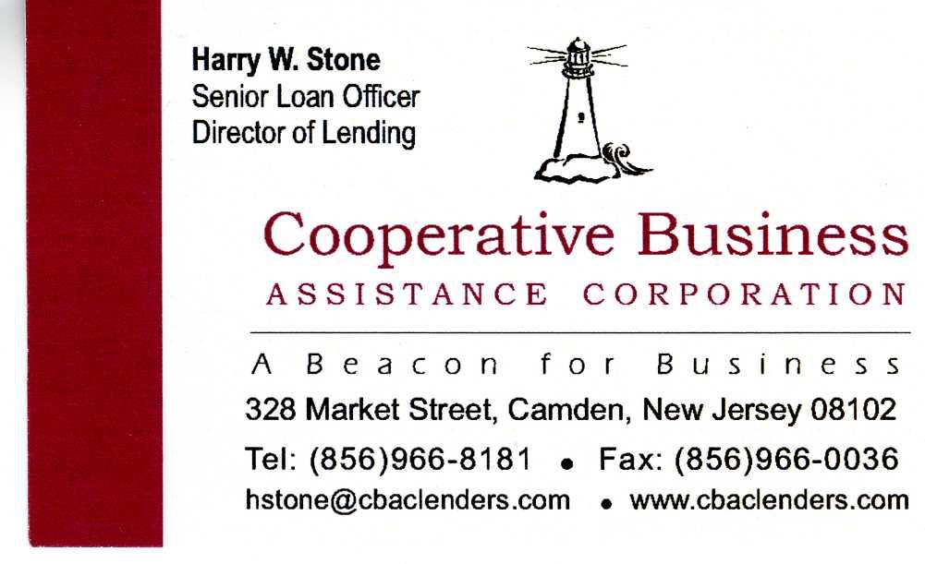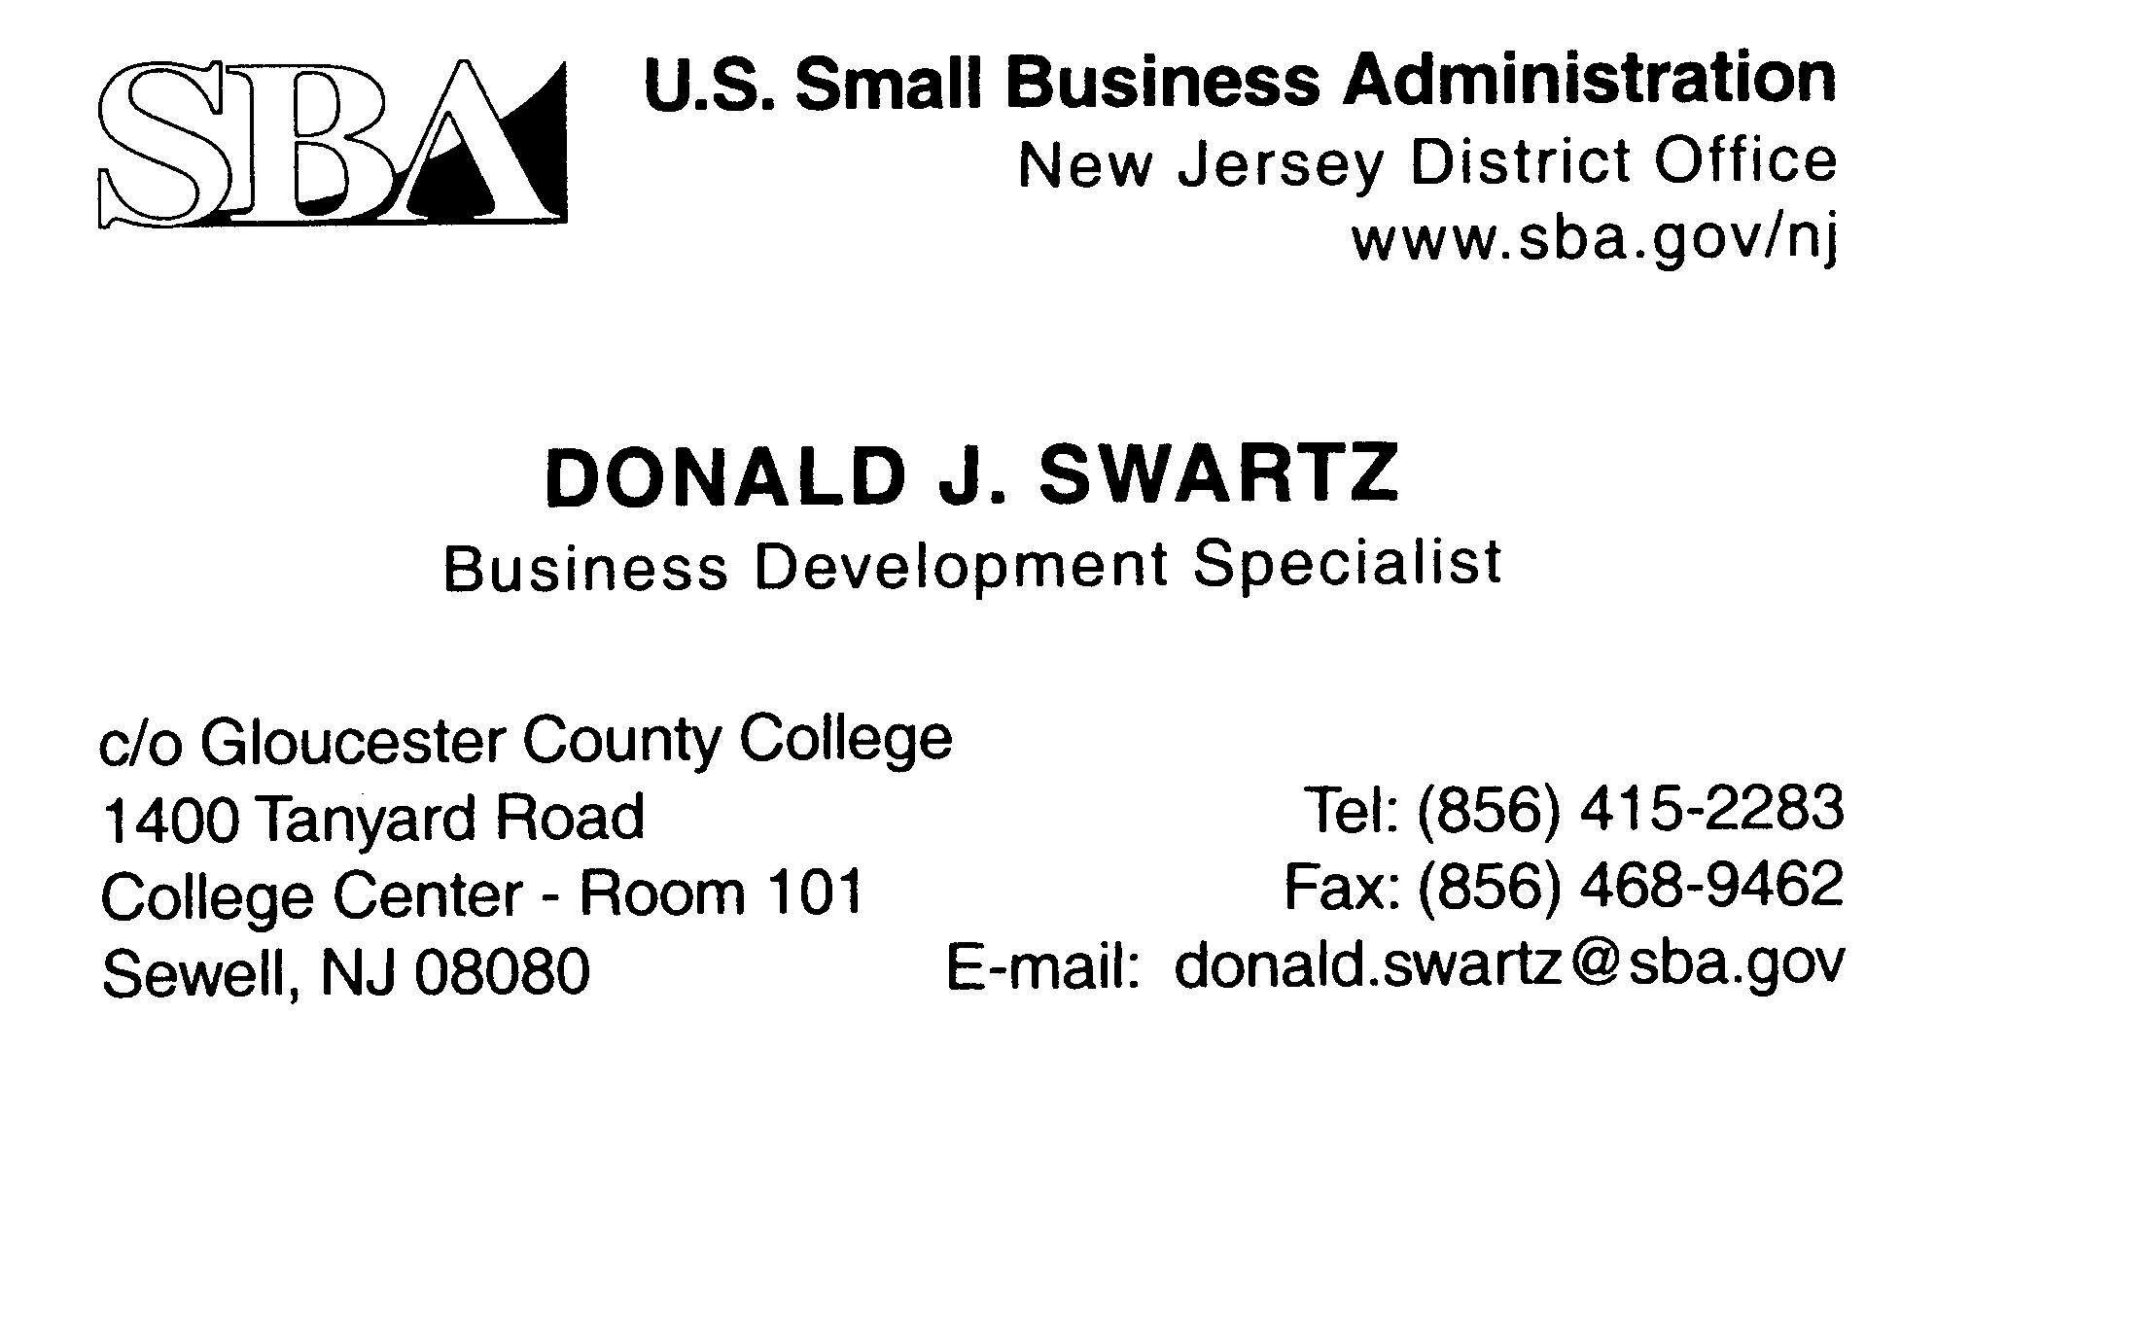EARN A

## Lot 14

**TRAINING CERTIFICATE**

**To earn a Basic Entrepreneurial Training Certificate you need to** complete the Entrepreneurial Training Series, which consists of; *Starting a Business from A - Z, Writing a Business Plan and Successfully Marketing Your Small Business*. The cost of the Certificate is included in the price of the program. The following application needs to be completed, after the completion of the classes. In order to process the Certificate courses must be taken **and application completed** within a twelve (12) month period. If you have any questions, please call the NJSBDC - Rutgers University - Camden at 856 - 225 - 6221.

___________________ ___________________________________________

Date Signature

* Basic Entrepreneurial Skills Training Certificate (Please complete the following)

|  |  |  |
| --- | --- | --- |
| **Title** | **Date** | **Location** |
| Starting a Business From A - Z |  |  |
| Writing a Business Plan |  |  |
| Successfully Marketing Your Small Business |  |  |

For the Basic Entrepreneurial Training Certificate you must have attended Starting a Small Business from A - Z, Financing a Business, Writing a Business Plan, and Successfully Marketing Your Small Business.

* Advanced Entrepreneurial Certificate

THIS CERTIFICATE IS ISSUED BY THE COUNTY COLLEGE AT WHICH YOU ATTEND THE PROGRAM.

* Accounting and QuickBooks Certificate (Please complete the following)

|  |  |  |
| --- | --- | --- |
| **Title** | **Date** | **Location** |
| Accounting Fundamentals |  |  |
| QuickBooks (Basic) |  |  |
| QuickBooks (Advanced) |  |  |

**Note: It is the applicant’s responsibility to be sure that he or she has registered by completing the sign - in sheet at each program.**

**NJSBDC - Rutgers University - Camden**

**419 Cooper Street**

**Camden, NJ 08102**

**The following information must be provided in order to receive your certificate.**

NAME: _____________________________________________________________________________

BUSINESS NAME (optional): ___________________________________________________________

MAILING ADDRESS: _________________________________________________________________

CITY: ____________________________________ STATE: _______________ ZIP: ____________

DAY PHONE: _____________________________ EVENING PHONE: ________________________

E - MAIL:_____________________________________________________________________________

**Training by Course Title**

##### BASIC ENTREPRENEURIAL SKILLS CERTIFICATE SERIES

##### STARTING A BUSINESS FROM A - Z

This course is designed for entrepreneurs intending to start or have recently started a small business. It examines legal forms of doing business in New Jersey, how to register a business, setting up bookkeeping records, Federal and State taxation, payroll, insurance and licensing. Materials: Workbook and disk.

|  |  |  |  |  |  |  |  |
| --- | --- | --- | --- | --- | --- | --- | --- |
| **Date** | **Location** | **Day** | **Time** | **Fee** | **Phone** | **City** | **County** |
| 01/30/14 02/06/14 | Gloucester County College (2 Parts) | Thursday Thursday | 6 - 9 pm | $ 115 | 856-415-2216 | Sewell | Gloucester |
| 02/26/14 03/05/14 | Burlington County College - Training Center  (2 Parts) | Wednesday Wednesday | 6 - 9 pm | $ 115 | 609-894-9311  ext 3027 | Mt. Laurel | Burlington |
| 03/06/14 03/20/14 | Gloucester County College (2 Parts) | Thursday Thursday | 6 - 9 pm | $ 115 | 856-415-2216 | Sewell | Gloucester |
| 05/21/14 05/28/14 | Burlington County College - Training Center  (2 Parts) | Wednesday Wednesday | 6 - 9 pm | $ 115 | 609-894-9311  ext 3027 | Mt. Laurel | Burlington |

##### WRITING AN EFFECTIVE BUSINESS PLAN

Developing a business plan is one of the most important challenges you will face as an entrepreneur. The process of developing a good business plan requires an understanding and appreciation for the tools required to do it right. This six hour program was developed to guide you through that process and give you a hand - on systematic way to develop an outline, investigate and evaluate the resources and create a draft of your own business plan.

|  |  |  |  |  |  |  |  |
| --- | --- | --- | --- | --- | --- | --- | --- |
| **Date** | **Location** | **Day** | **Time** | **Fee** | **Phone** | **City** | **County** |
| 02/13/14 02/20/14 | Gloucester County College (2 Parts) | Thursday Thursday | 6 - 9 pm | $ 115 | 856-415-2216 | Sewell | Gloucester |
| 03/12/14 03/26/14 | Burlington County College - Training Center (2 Parts) | Wednesday Wednesday | 6 - 9 pm | $ 115 | 609-894-9311  ext 3027 | Mt. Laurel | Burlington |
| 03/27/14 04/03/14 | Gloucester County College (2 Parts) | Thursday Thursday | 6 - 9 pm | $ 115 | 856-415-2216 | Sewell | Gloucester |
| 06/04/14 06/11/04 | Burlington County College - Training Center (2 Parts) | Wednesday Wednesday | 6 - 9 pm | $ 115 | 609-894-9311  ext 3027 | Mt. Laurel | Burlington |

##### SUCCESSFULLY MARKETING YOUR SMALL BUSINESS

This is a basic How - To Marketing Class that covers some of the specific actions you can take to market your business. The class is designed for small businesses who want to start marketing their business today. It is also the second part of the MARKETING RESEARCH AND STRATEGIES 6 hour program.

|  |  |  |  |  |  |  |  |
| --- | --- | --- | --- | --- | --- | --- | --- |
| **Date** | **Location** | **Day** | **Time** | **Fee** | **Phone** | **City** | **County** |
| 02/27/14 | Gloucester County College | Thursday | 6 - 9 pm | $ 60 | 856-415-2216 | Sewell | Gloucester |

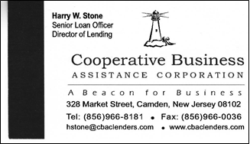

##### ACCOUNTING & QUICKBOOKS CERTIFICATE SERIES

##### ACCOUNTING FUNDAMENTALS

This course is designed to provide students with a fundamental knowledge of accounting and record keeping procedures and is the first course in “Accounting/QuickBooks Certificate Program”. Students will learn concepts needed for bookkeeping and become knowledgeable with accounting terminology used to operate financial software.

|  |  |  |  |  |  |  |  |
| --- | --- | --- | --- | --- | --- | --- | --- |
| **Date** | **Location** | **Day** | **Time** | **Fee** | **Phone** | **City** | **County** |
| 02/15/14 02/22/14 | Rutgers University  Business & Science Bldg (2 parts) | Saturday Saturday | 9 am – Noon | $ 120 | 856-225-6221 | Camden | Camden |

##### QUICKBOOKS (BASIC)

This introductory course explains how QuickBooks can simplify the accounting process for a small business. Using QuickBooks students will learn 1) how to set up a company 2) how to record business transactions 3) to understand QuickBooks reports and 4) the components of financial statements. (Participants should have understanding of basic accounting concepts or have taken “Accounting Fundamentals” as well having basic computer keyboarding skills). 2 sessions. 6 total hours. .

|  |  |  |  |  |  |  |  |
| --- | --- | --- | --- | --- | --- | --- | --- |
| **Date** | **Location** | **Day** | **Time** | **Fee** | **Phone** | **City** | **County** |
| 03/08/14 03/15/14 | Rutgers University-Camden School of Business (2 parts) | Saturday | 9:00 – noon | $ 120 | 856-225-6221 | Camden | Camden |

##### QUICKBOOKS (ADVANCED)

##### This intermediate course is designed to put the student in a simulated real business environment managing both the Customers/Sales and Vendors/Expenses capabilities in QuickBooks. Accounts Receivable transactions include creating customer and job lists, setting up item (product) lists, creating quotes, tracking employee time for customer jobs, applying customer payments, journal entries, and accounts receivable reporting. Accounts Payable transactions include setting up vendors, preferences, processing vendor invoices, credit card statement payments, applying invoices to customer jobs, batch and single check process, voiding checks, journal entries and Account Payable reporting. QuickBooks (Basic) or a good basic knowledge of QuickBooks if prerequisite. 3 sessions. 9 hours total.

|  |  |  |  |  |  |  |  |
| --- | --- | --- | --- | --- | --- | --- | --- |
| **Date** | **Location** | **Day** | **Time** | **Fee** | **Phone** | **City** | **County** |
| 03/29/14 04/05/14 04/12/14 | Rutgers University-Camden School of Business (3 parts) | Saturday | 9:00 – noon | $ 150 | 856-225-6221 | Camden | Camden |





##### ADVANCED ENTREPRENEURIAL CERTIFICATE SERIES

**The Advanced Entrepreneurial Certificate requires all the workshops in the Basic Entrepreneurial Certificate plus the following workshops**.

##### FINANCING A SMALL BUSINESS

One of the primary challenges facing a new business is obtaining the necessary funding to start or expand the business. This course explains the criteria used by lenders to evaluate a potential borrower. Sources of financing will also be explored, including bank and non - bank lenders: the SBA; Micro - lenders; Venture Capitalists; and others. The borrowing basics will be directly tied to the contents of a business plan/loan proposal.

|  |  |  |  |  |  |  |  |
| --- | --- | --- | --- | --- | --- | --- | --- |
| **Date** | **Location** | **Day** | **Time** | **Fee** | **Phone** | **City** | **County** |
| 04/02/14 | Burlington County College - Training Center | Wednesday | 6 - 9 pm | $ 60 | 609-894-9311  ext 3027 | Mt. Laurel | Burlington |
| 04/10/14 | Gloucester County College | Thursday | 6 - 9 pm | $ 60 | 856-415-2216 | Sewell | Gloucester |

##### RECORDING BUSINESS TRANSACTIONS

This is a practical application class designed to teach the business owner how to record specific transactions in a manual record keeping system. Disbursement and Sales journals will be prepared as well as Accounts Receivable, and Accounts Payable Ledgers. Sample transactions will be used to generate business activity through the end of an accounting period and formulate financial statements.

|  |  |  |  |  |  |  |  |
| --- | --- | --- | --- | --- | --- | --- | --- |
| **Date** | **Location** | **Day** | **Time** | **Fee** | **Phone** | **City** | **County** |
| 04/09/14 | Burlington County College - Training Center | Wednesday | 6 - 9 pm | $ 60 | 609-894-9311  ext 3027 | Mt. Laurel | Burlington |
| 04/17/14 | Gloucester County College | Thursday | 6 - 9 pm | $ 60 | 856-415-2216 | Sewell | Gloucester |

### MARKETING RESEARCH AND STRATEGIES – (2 Parts**)**

Examine in detail the two critical aspects of marketing. The first session will focus on marketing research techniques and tools. This program is for new and existing businesses. The second session covers strategies and actions you can take to market your business. (The second session of this program is the equivalent to SUCCESSFULLY MARKETING YOUR SMALL BUSINESS – described on page 4)

|  |  |  |  |  |  |  |  |
| --- | --- | --- | --- | --- | --- | --- | --- |
| **Date** | **Location** | **Day** | **Time** | **Fee** | **Phone** | **City** | **County** |
| 04/16/14 04/23/14 | Burlington County College - Training Center (2 Parts) | Wednesday Wednesday | 6 - 9 pm | $ 115 | 609-894-9311  ext 3027 | Mt. Laurel | Burlington |
| 04/24/14 05/01/14 | Gloucester County College | Thursday | 6 - 9 pm | $ 115 | 856-415-2216 | Sewell | Gloucester |

##### UNDERSTANDING FINANCIAL STATEMENTS

Gain an understanding of basic business financial statements (Balance Sheet, Income Statement, and Statement of Cash Flow). The class will demonstrate how the review and analysis of the financial statements can provide you with the information needed to improve profitability and/or grow your business. Detailed discussion of revenues and expense items, forecasting and trend analysis.

|  |  |  |  |  |  |  |  |
| --- | --- | --- | --- | --- | --- | --- | --- |
| **Date** | **Location** | **Day** | **Time** | **Fee** | **Phone** | **City** | **County** |
| 04/30/14 | Burlington County College - Training Center | Wednesday | 6 - 9 pm | $ 60 | 609-894-9311  ext 3027 | Mt. Laurel | Burlington |
| 05/08/14 | Gloucester County College | Thursday | 6 - 9 pm | $ 60 | 856-415-2216 | Sewell | Gloucester |

##### BUSINESS OWNERSHIP, CONTRACTS AND AGREEMENTS

This class provides a basic understanding of *business contract law* with an overview of the different types of contracts (employment, supplier, customer), with a description of situations requiring attorney consultation. Topics include Legal Structures, Partnerships and Partnership Agreements, Corporation and Shareholder Agreements.

|  |  |  |  |  |  |  |  |
| --- | --- | --- | --- | --- | --- | --- | --- |
| **Date** | **Location** | **Day** | **Time** | **Fee** | **Phone** | **City** | **County** |
| 05/07/14 | Burlington County College - Training Center | Wednesday | 6 - 9 pm | $ 60 | 609-894-9311  ext 3027 | Mt. Laurel | Burlington |
| 05/15/14 | Gloucester County College | Thursday | 6 - 9 pm | $ 60 | 856-415-2216 | Sewell | Gloucester |

BUSINESS START - UP

##### NEW BUSINESS Q & A

Starting a new business? This program is a basic overview of what you need to know to get your business up and running. Topics include: Business Planning, Legal Formation, Registration requirements and how to find and use the many resources available to help you get started.

|  |  |  |  |  |  |  |  |
| --- | --- | --- | --- | --- | --- | --- | --- |
| Date | Location | Day | Time | Fee | Phone | City | County |
| 01/17/14 | Waterfront Technology Center | Friday | 10 am –  noon | $ 25 | 856–225-6221 | Camden | Camden |
| 01/31/14 | Waterfront Technology Center | Friday | 10 am –  noon | $ 25 | 856–225-6221 | Camden | Camden |
| 02/14/14 | Waterfront Technology Center | Friday | 10 am –  noon | $ 25 | 856–225-6221 | Camden | Camden |
| 02/28/14 | Waterfront Technology Center | Friday | 10 am –  noon | $ 25 | 856–225-6221 | Camden | Camden |
| 03/14/14 | Waterfront Technology Center | Friday | 10 am –  noon | $ 25 | 856–225-6221 | Camden | Camden |
| 03/28/14 | Waterfront Technology Center | Friday | 10 am –  noon | $ 25 | 856–225-6221 | Camden | Camden |
| 04/11/14 | Waterfront Technology Center | Friday | 10 am –  noon | $ 25 | 856–225-6221 | Camden | Camden |
| 04/25/14 | Waterfront Technology Center | Friday | 10 am –  noon | $ 25 | 856–225-6221 | Camden | Camden |
| 05/09/14 | Waterfront Technology Center | Friday | 10 am –  noon | $ 25 | 856–225-6221 | Camden | Camden |
| 05/23/14 | Waterfront Technology Center | Friday | 10 am –  noon | $ 25 | 856–225-6221 | Camden | Camden |
| 06/06/14 | Waterfront Technology Center | Friday | 10 am –  noon | $ 25 | 856–225-6221 | Camden | Camden |
| 06/20/14 | Waterfront Technology Center | Friday | 10 am –  noon | $ 25 | 856–225-6221 | Camden | Camden |



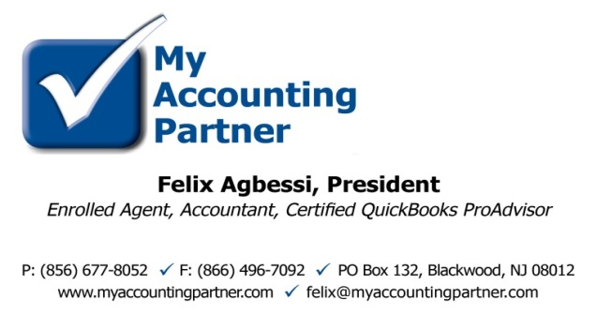

##### FINANCING

##### BUILDING & FINANCING YOUR BUSINESS WITH THE SBA

### This program is designed to provide individuals that are in business or thinking of starting a business with information on the business loan programs and technical assistance programs offered by the SBA. Leading area bank lending officers will also be on hand to discuss their role in the SBA’s Guaranteed Lending Program. Lenders will discuss what goes into a good loan proposal, how to increase your chances of getting a loan and how to get through the loan application process.

|  |  |  |  |  |  |  |  |
| --- | --- | --- | --- | --- | --- | --- | --- |
| **Date** | **Location** | **Day** | **Time** | **Fee** | **Phone** | **City** | **County** |
| 03/27/14 | Gloucester County Main Library | Thursday | 1 – 3 pm | Free | 856-225-6221 | Mullica Hill | Gloucester |
| Oct TBD | Burlington County Main Library | TBD | TBD | Free | 856-225-6221 | Westampton | Burlington |

##### EASY RECORD KEEPING FOR SMALL BUSINESS

### This workshop will include the basics of recording transactions in a simple record keeping system for the busy business owner.

|  |  |  |  |  |  |  |  |
| --- | --- | --- | --- | --- | --- | --- | --- |
| **Date** | **Location** | **Day** | **Time** | **Fee** | **Phone** | **City** | **County** |
| 10/15/14 | LAEDA | Wednesday | 6 – 8 pm | Free | 856-338-1177 X3316 | Camden | Camden |

##### MEET THE LENDERS ROUNDTABLE

### Meet the Lenders Roundtable is a great forum for Entrepreneurs to meet with commercial loan officers from local banks and discuss their financing needs. You will have the opportunity to have a face to face with the lenders and have them review a Business Plan Executive Summary and Financial Projections for content, form and feasibility.

|  |  |  |  |  |  |  |  |
| --- | --- | --- | --- | --- | --- | --- | --- |
| **Date** | **Location** | **Day** | **Time** | **Fee** | **Phone** | **City** | **County** |
| 06/12/13 | Waterfront Technology Center | Thursday | 9 am – noon | Free | 856-225-6221 | Camden | Camden |

##### MARKETING

##### `

##### BUSINESS OWNERS’ TOOLKIT

Find the knowledge you need to build a business plan, gauge the market potential of your product or service, position your business versus the competition, navigate government and legal requirements, and tap local resources and contacts. Let an expert researcher with experience in private sector business intelligence show you how to leverage a goldmine of online library resources, local government organizations, and websites at this hands-on workshop. You do NOT need a Burlington County Library System Card to attend. Maximum participants – 11 per session

|  |  |  |  |  |  |  |  |
| --- | --- | --- | --- | --- | --- | --- | --- |
| **Date** | **Location** | **Day** | **Time** | **Fee** | **Phone** | **City** | **County** |
| 03/13/14 | Burlington County Library HQ Tech Center | Thursday | 6:15 – 8:45 pm | Free | 609-267-9660  ext 2 or online | Westampton | Burlington |
| 06/26/14 | Burlington County Library HQ Tech Center | Thursday | 6:15 - 8:45 pm | Free | 609-267-9660  ext 2 or online | Westampton | Burlington |

##### SMALL BUSINESS TAXES

##### SMALL BUSINESS TAXES

The following topics will be discussed: types of organizations, record keeping and overview of employment taxes.

|  |  |  |  |  |  |  |  |
| --- | --- | --- | --- | --- | --- | --- | --- |
| **Date** | **Location** | **Day** | **Time** | **Fee** | **Phone** | **City** | **County** |
| TBD | Waterfront Technology Center | Friday | 10 am –  1 pm | Free | 856–225-6221 | Camden | Camden |

##### ***SPECIAL PROGRAMS***

##### BUYING/SELLING AND VALUING A BUSINESS

Ready to call it a day (or begin a new one)? If you’re thinking of selling or buying a business, is it priced right? This workshop will discuss the right reasons for buying or selling a business, alert you to possible pitfalls and problems and give you the tools to assess the value of a business. The focus of the workshop is to develop quantitative data that will help establish a meeting of the minds which in turn will provide financial value and a comfort level for the buyer and the seller. Business owners interested in succession planning, estate planning or insurance planning would also find this workshop enlightening.

|  |  |  |  |  |  |  |  |
| --- | --- | --- | --- | --- | --- | --- | --- |
| **Date** | **Location** | **Day** | **Time** | **Fee** | **Phone** | **City** | **County** |
| TBD | Waterfront Technology Center | Tuesday | 9 am – noon | $ 50 | 856-225-6221 | Camden | Camden |

##### CREDIT MANAGEMENT FOR ENTREPRENEURS

The importance of having a GOOD CREDIT RECORD cannot be undersold especially when it comes to small business. Access to financing is a critical factor in starting and growing a successful business and your personal credit history is the most important factor in the pursuit of loans and lines of credit. This program will help you to understand your credit history as it is reported by the credit bureaus and will provide the steps to repairing your credit.

|  |  |  |  |  |  |  |  |
| --- | --- | --- | --- | --- | --- | --- | --- |
| Date | Location | Day | Time | Fee | Phone | City | County |
| 06/18/14 | LAEDA | Wednesday | 6 – 8 pm | Free | 856-338-1177  ext 3316 | Camden | Camden |

##### CUSTOMIZED BUSINESS ANSWERS – SMALL GROUP SESSIONS @ THE LIBRARY

Let a skilled researcher with experience in corporate business research help you find the answers YOU need to move your business forward. Do you need to: create a targeted list for a marketing campaign? Identify sources for financing your company? Keep on top of trends driving the market for your product/services? Pull together data for your business or marketing plan? Develop a unique concept that sets you apart from the competition? Join a small group of no more than three people for a 1 hour session customized to the participants’ needs. If additional assistance is needed, there will be the option of scheduling a later one-on-one session with the *instructor. You do NOT need a Burlington County Library System Card to attend. Prior registration required*

|  |  |  |  |  |  |  |  |
| --- | --- | --- | --- | --- | --- | --- | --- |
| **Date** | **Location** | **Day** | **Time** | **Fee** | **Phone** | **City** | **County** |
| 01/07/14 | Burlington County  Library Headquarters | Tuesday | 2:30 - 3:30 pm | Free | 609-267-9660  ext 2 or online | Westampton | Burlington |
| 01/21/14 | Burlington County  Library Headquarters | Tuesday | 6:30 – 8:00 pm | Free | 609-267-9660  ext 2 or online | Westampton | Burlington |
| 02/04/14 | Burlington County  Library Headquarters | Tuesday | 2:30 - 3:30 pm | Free | 609-267-9660  ext 2 or online | Westampton | Burlington |
| 02/20/14 | Burlington County Library Headquarters | Tuesday | 6:30 – 8:00 pm | Free | 609-267-9660 ext 2 or online | Westampton | Burlington |
| 03/04/14 | Burlington County  Library Headquarters | Tuesday | 6:30 - 8:00 pm | Free | 609-267-9660  ext 2 or online | Westampton | Burlington |
| 03/25/14 | Burlington County  Library Headquarters | Tuesday | 2:30 – 3:30 pm | Free | 609-267-9660  ext 2 or online | Westampton | Burlington |
| 04/08/14 | Burlington County  Library Headquarters | Tuesday | 2:30 – 3:30 pm | Free | 609-267-9660  ext 2 or line | Westampton | Burlington |
| 04/29/14 | Burlington County  Library Headquarters | Tuesday | 6:30 – 8:00 pm | Free | 609-267-9660  ext 2 or online | Westampton | Burlington |
| 05/08/14 | Burlington County  Library Headquarters | Tuesday | 2:30 – 3:30 pm | Free | 609-267-9660  ext 2 or onliine | Westampton | Burlington |
| 05/20/14 | Burlington County  Library Headquarters | Tuesday | 6:30 – 8:00 pm | Free | 609-267-9660  ext 2 or onliine | Westampton | Burlington |
| 06/10/14 | Burlington County  Library Headquarters | Tuesday | 2:30 – 3:30 pm | Free | 609-267-9660  ext 2 or onliine | Westampton | Burlington |
| 06/24/14 | Burlington County  Library Headquarters | Tuesday | 6:30 – 8:00 pm | Free | 609-267-9660  ext 2 or onliine | Westampton | Burlington |

##### FP3 CERTIFICATION WORKSHOP FOR 8(A), HUB ZONE AND WOSB

This Federal Certification workshop is presented by the NJSBDC Procurement Program. The 8(a) Business Development Program is SBA’s effort to promote equal access for socially and economically disadvantaged individuals to participate in the business sector of the nation’s economy. The HUBZone Empowerment Contracting Program seeks to encourage economic development in historically underutilized area.

|  |  |  |  |  |  |  |  |
| --- | --- | --- | --- | --- | --- | --- | --- |
| **Date** | **Location** | **Day** | **Time** | **Fee** | **Phone** | **City** | **County** |
| 04/17/14 | Waterfront Technology Center | Thursday | 9 am – 11:30 am | Free | 856-225-6221 | Camden | Camden |

##### POWERPOINT FOR BUSINESS

PowerPoint is a valuable tool for presenting to staff, managers, and potential funders. In this hands-on workshop, you will learn the basics of using this tool by creating a brief PowerPoint presentation based on a sample business plan. Bring your own floppy disk or flash drive. (Disks can be purchased for $1.00 at the library.) MOUSE SKILL IS REQUIRED. You do NOT need a Burlington County Library System Card to attend. Registration is required. Maximum participants – 11 per session

|  |  |  |  |  |  |  |  |
| --- | --- | --- | --- | --- | --- | --- | --- |
| **Date** | **Location** | **Day** | **Time** | **Fee** | **Phone** | **City** | **County** |
| 04/24/14 | Burlington County Library HQ Tech Center | Thursday | 6:15 – 8:45 pm | Free | 609-267-9660  ext 2 or online | Westampton | Burlington |

##### *NOTES*

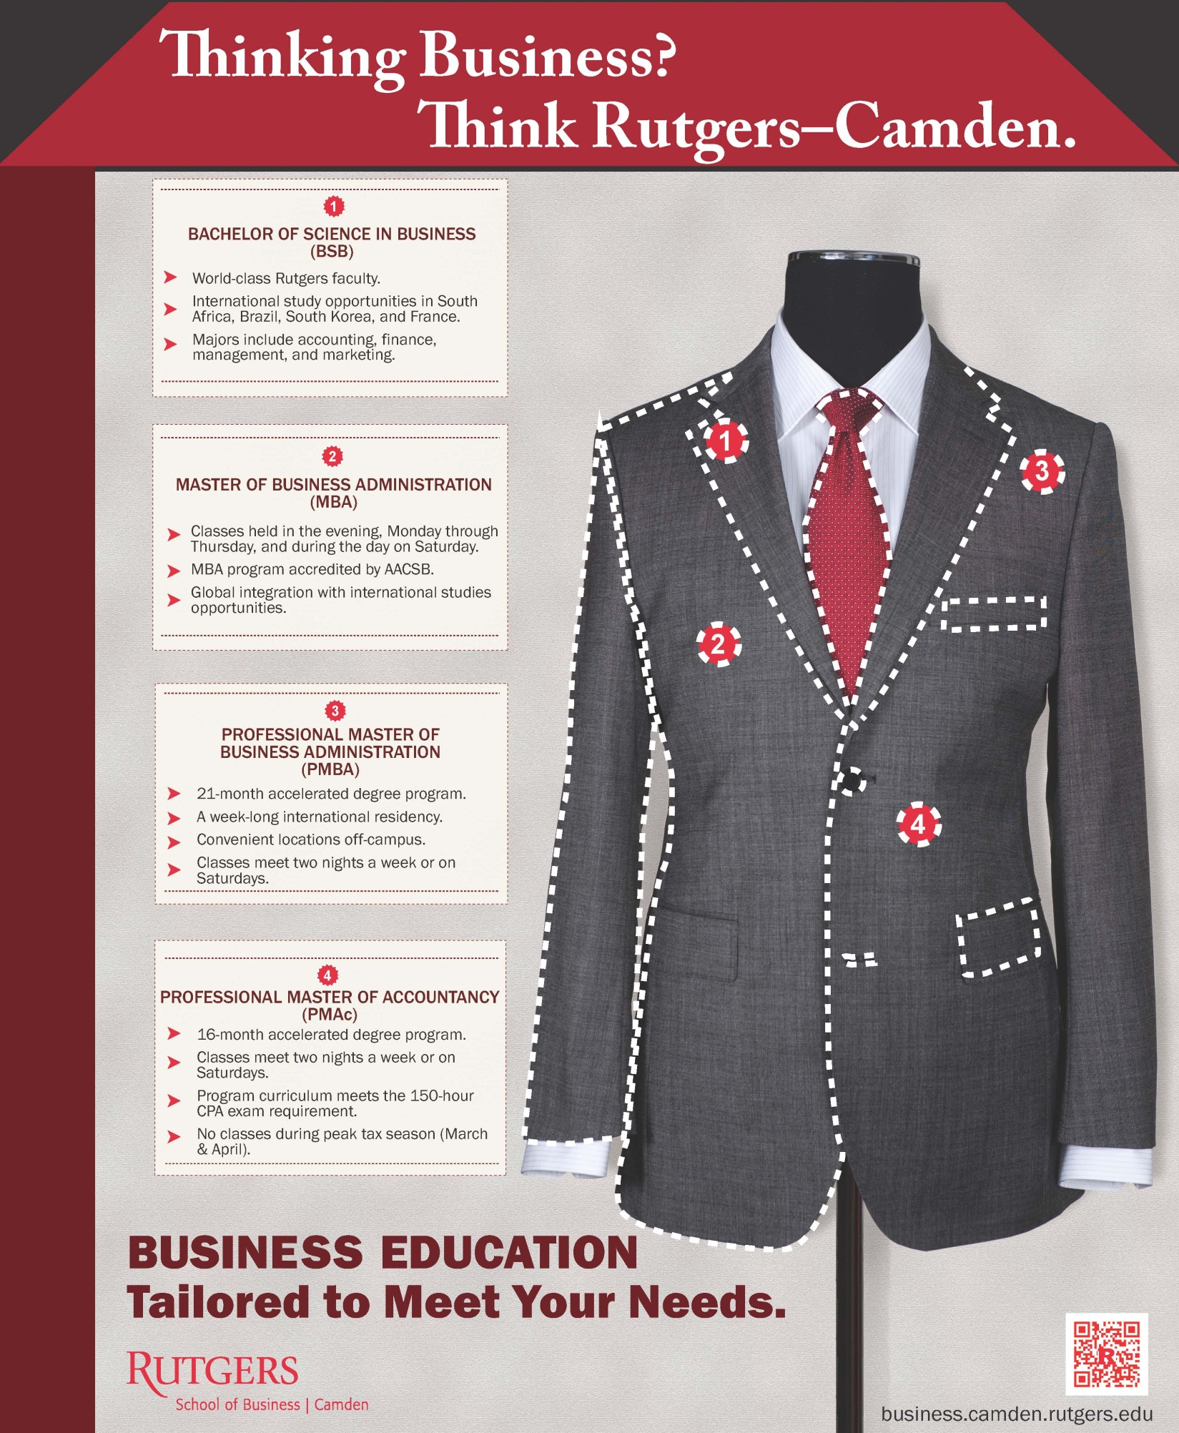

##### 

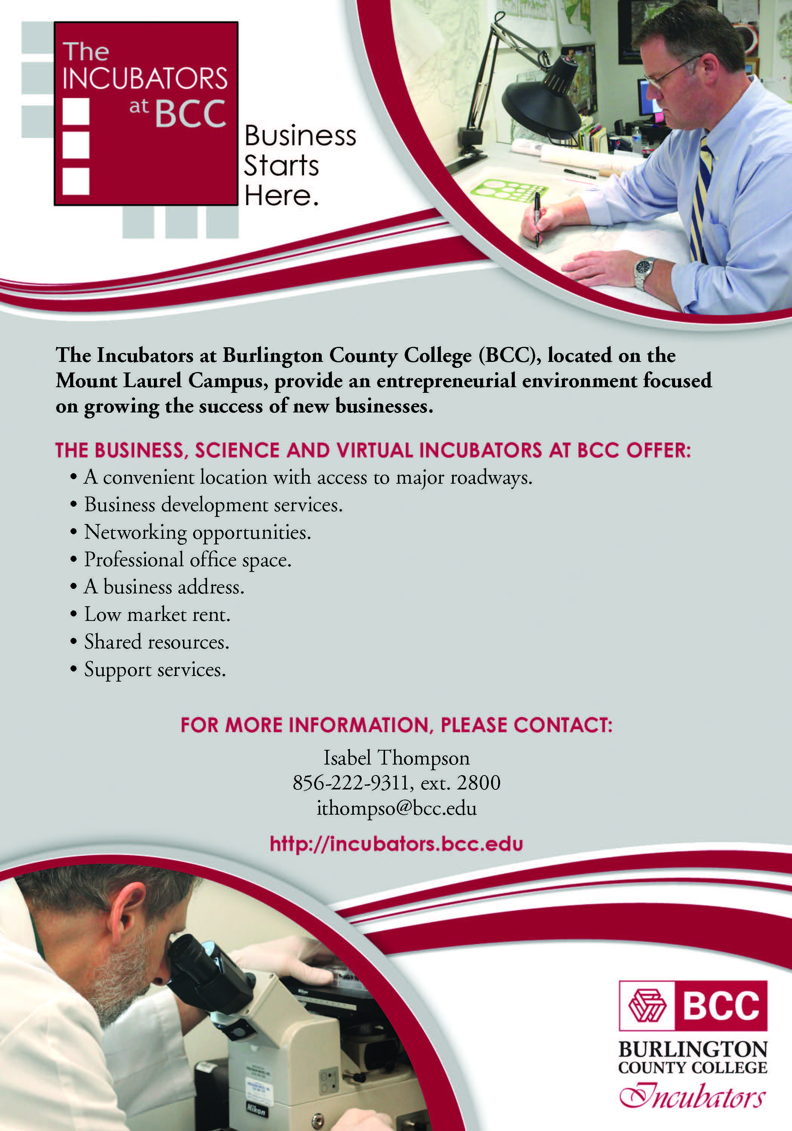

**General Information Fact Sheet**

The following information has been compiled by the New Jersey Small Business Development Center (RSBDC), a member of the NJ Small Business Development Center Network, A PARTNERSHIP FOR SMALL BUSINESS DEVELOPMENT Sponsored By: the U.S. Small Business Administration (SBA), The New Jersey Economic Development Authority (NJEDA) and Rutgers University, School of Business, Camden, NJ. It is an effort to provide answers too many of the most often asked questions about starting a small business in New Jersey. Important: This information is instructional only, and does not replace the need for legal advice. Be advised to check with an attorney before completing any forms that are specific to starting your business. For more information contact the **NJSBDC - Rutgers University – Camden at 856 - 225 – 6221.**

1. LOCAL REQUIREMENTS

Local business licensing & zoning requirements must be checked with the individual municipal zoning boards and be in compliance with local and/or county requirements. Fire inspections are also scheduled through your municipality. Likewise, be sure to check local city tax obligations.

**2. TRADENAME for SOLE PROPRIETOR**

If doing business under your OWN NAME, the registration of the business is desired, but not required by law. If trading under any name ***other than your own name***, or a name that includes the designation “and Company” or “& Co.,” you are required to register your business’s name with the County Clerk of the county in which your business is located. Registration of your trade name in a county generally protects your trade name from use by other businesses in that county. Frequently, businesses that prefer not to incorporate simply register their business name in each of New Jersey's 21 counties. However, if another business incorporates under your business trade name and ads "Inc." to that trade name, your business name may not be protected. In addition, the requirements in #5 also apply.

#### County Clerk Listing Phone Number Fee

Burlington County 609 - 265 - 5181 $60

Camden County 856 - 225 - 5330 $57

Gloucester County 856 - 853 - 3237 $51

Salem County 856 - 935 - 7510 $50

**3 INCORPORATION, Limited Liability Company**

**Limited Partnership, Limited Liability Partnership**

If you are starting a corporation, Limited Liability Company, Limited Partnership or Limited Liability Partnership you are required to file with the State of New Jersey. You can reserve the business name for use prior to filing your original business certificate with the state. Use Business Entity Name Availability Check & Reservation –Registration Service to check on the availability of a business entity name and/or to reserve or register an available name for use in the State of New Jersey. Name reservations are provided for domestic (in state) business entities and remain in effect for 120 days. In addition, you can “browse” existing business names free of charge before placing an order. To obtain this information by mail or phone contact the Division of Revenue Business Services.

Division of Revenue Business Services, NJ Department of Treasury, PO Box 308, 225 W. State Street, Trenton, NJ 08625 – 0308 ph: 609-292-9292

www.state.nj.us/njbgs

Approximate Cost: Corporate filing fee $125.00. Note: *For a corporation to be considered operational, it must obtain and complete a corporate kit.* The corporate kit can be purchased from any business stationary store. The requirements in #5 also apply.

**4 INFORMATION OF GENERAL PARTNERSHIP**

Persons organizing a general partnership must file a certificate stating the firm's name, the nature of the business, and the name of the partners with the County Clerk's office in each county where the business will be physically located. The filing fee will differ in each county. Similar certificates must be filed in the event of discontinuance, dissolution, or changes in the partnership. A partnership agreement is essential in protecting your individual and collective rights. The requirements in #5 also apply.

**5. TAX INFORMATION**

**FEDERAL**: Employers and all legal entities must apply for their federalEmployer Identification Number (Form SS-4), to comply with the federal income tax, social security, and unemployment insurance. Call 1-800-TAX-3676 to request Form SS-4. To secure an EIN quickly, call 800-829-1040 (follow prompts) after you have completed the Form SS-4 the EIN number will be issued over the phone. Fax on demand, please call 703-368-9694. To view and/or download the form click on the IRS website: www.irs.gov.

**STATE:** Anyone establishing a business in New Jersey must register it with the NJ Division of Revenue (form NJ - REG); even if you do not think, you will be collecting or withholding taxes. This registration is required to be filed at least **15 business days prior** to the day the business opens.

**To register online** **with the NJ Division of Revenue**: Go to: [www.state.nj.us/njbgs](http://www.state.nj.us/njbgs) Then choose Business Formation and Registration and follow the options provided. This site also includes Public Records filing. You may also view, download, and/or print registration forms, and **mail** the completed forms to: Client Registration Bureau, NJ Division of Revenue. PO Box 252, Trenton, NJ 08625 - 0252, (609) - 292 - 1730**.**

**Taxation Customer Service Center**: 609 - 292 - 6400, or toll - free, 1 - 800 - 323 - 4400 (automated system).

**Sales Tax Law:** The New Jersey Sales and Use Tax Act impose a tax of 7% upon the receipts of every retail sale of tangible personal property and the sale of certain services, except as otherwise provided in the Act. This means that in New Jersey, most items and most services performed upon tangible personal property are taxable unless they were specifically exempted by law. Exempt items include: most food intended for at - home or off - premises preparation and consumption, most clothing and footwear, disposable paper products for household use, prescription drugs and over - the - counter drugs sold for the relief of pain.

*The Sales and Use Tax act has been revised the new changes went into effect October 1, 2006*. It is important that you become aware of these changes.

To access the latest information go to: ***www.state.nj.us/treasury/taxation/*** go to*:* **News** to review the latest press releases on tax issues then go to***:* E - News** to sign up to receive all future updates by

e - mail.

New Hire* Reporting:

New Jersey Employers are now required to report new hires to the New Hire Operations Center. This program has been implemented to facilitate the collection of child support payments. New hires should be reported on the State of New Jersey New Hire Reporting Form.*

If you have questions, or to receive a copy of the reporting form contact:

New Hire Operations Center

P.O. Box 4654, Trenton, NJ 08650 - 4654

1 - 877 - NJ - HIRES (654 - 4737)

Fax: 1 - 800 - 304 - 4901

www.NJ-newhire.com

E - mail: NewJersey@NJ-newhire.com

*A copy of the New Hire Report Form is included in the

NJ - REG package.

**6. EMPLOYER INSURANCE**

If you open a business and hire at least one employee, you must indicate this when you complete the NJ-REG (see #5). If you start your business with no employees but subsequently hire employees, you must notify the N.J. Division of Revenue by submitting a Request for Change of Registration Information (Form REG-C-L). This form is included in the NJ-REG package.

You may obtain information regarding workers compensation by writing to the Division of Workers Compensation Labor & Industry Building P.O. Box 381 Trenton New Jersey 08625-0381

Call 609-633-6400 for an application and for further information; or to receive the booklet: Simplifying New Jersey's Unemployment Compensation & Temporary Disability Benefits Laws for Employers (B-426).

1. **ENTREPRENEURIAL ASSISTANCE IN**

**THE STATE OF NEW JERSEY**

***New Jersey Business Portal*** – The web-based portal is designed to assist small business owners and entrepreneurs considering a business opportunity to locate descriptive information and contact sources to help their business grow while they create jobs in New Jersey. The categories of services are:

* Starting a business
* Workforce training and programs
* Licenses and Permits
* Tax Center
* Business Registration and Information Services
* Financing and Incentives
* Small and Mid-Size Businesses

[http://www***.***newjerseybusiness.gov](http://www.newjerseybusiness.gov)

Customer Service Call Center: 866-534-7789

***New Jersey Economic Development Authority (NJEDA)*** assists in the overall goal to strengthen New Jersey's economy and create jobs. The Small Business Services group accomplishes this by encouraging the start-up, growth and expansion of small businesses and women and minority enterprises by offering information and assistance and by shaping public policies that affect the small business community. It serves as a clearinghouse, information and referral center for start-up and established small businesses that employ 100 workers or less on topics from financing and franchises to marketing and management. It creates and strengthens partnerships with public and private sector organizations to facilitate new business development and to strengthen existing firms. If you are contemplating starting your own business, or looking to expand in New Jersey, write or call the:

New Jersey Economic Development Authority

Small Business Services

ATTN: Marion Zajac

36 West State Street

PO Box 990, Trenton, NJ 08625-0990

609-858-6695

www.njeda.com

***Entrepreneurial Training Institute (ETI)*** 908-527-1166

[www.ucedc.com](http://www.ucedc.com)

ETI is training program offered by UCEDC under contract with the NJEDA and designed to promote small business ownership including minorities and women. Classes are available statewide. ETI assists participants in evaluating their readiness for entrepreneurship, evaluating market opportunities and creating a credible business plan. After this feedback and coaching, entrepreneurs are mentored and, if needed, introduced to funders. Fee-based.

***Financing of Small and Mid-Size Businesses*** 609-777-4531 [www.njeda.com](http://www.njeda.com)

Visit the website to assess the various financing and incentive products offered through the New Jersey Economic Development Authority (NJEDA).

8 REGISTRATION & CERTIFICATION

SMALL BUSINESS ENTERPRISE (SBE) &

WOMEN/MINORITY BUSINESS  
 ENTERPRISE (M/WBE) PROGRAM

The State of New Jersey’s Small Business Set - Aside program includes goals that 25% of state contract and purchase order dollars be awarded to Small Business Enterprises (SBE). Obtaining a SBE registration will add your company’s name to the SAVI database, which is the state’s listing of vendors eligible to participate in state-based SBE selected bid offerings. State agency buyers are encouraged to use this database as a resource when they are searching for SBE’s. In order to qualify, businesses must complete the Small Business Registration Form and meet state program criteria. The registration fee is $100 for a 3- year registration period.

A Minority Business Enterprise (MBE) or a Women Business Enterprise (WBE) certification serves to declare a business as minority and/or women-owned, thus allowing the business to compete for minority and/or women business opportunities and set aside programs. Approved participants in this program are also added to the state database, SAVI (refer above). The certification fee is $100 for a 3-year certification period.

**NOTE: Some States and municipalities who have minority and women set aside contracts require that vendors obtain this designation in their ‘home” state in order to compete for contracts in the awarding states or municipality.**

Additional programs and services for SMWBE’s include on-line resources to facilitate access to accurate and up-to-date contracting related information and services. They include:

**Bid Opportunities Database:** A single source for accessing bid opportunity information across more than 100 state agencies, authorities, commissions, colleges and universities, etc.

**Bid E-mail Notification:** Register and receive e-mail notification about bid opportunities that match your specific commodity code(s)

**Diversity Registry**: an online directory of S/M/WBE’s self declared as certified by non-DMWBD (state) entities. Provides SMWBE’s an opportunity to market to state buyers and prime contractors

The noted programs and services are managed by the Division of Minority and Women Business Development (DMWBD). You may obtain additional information, application forms, etc. by visiting http: //www.state.nj.us/njbusiness/contracting, emailing [dmwbd@treas.state.nj.us](mailto:dmwbd@treas.state.nj.us) or calling (609) 292-2146

**9. U.S. SMALL BUSINESS ADMINISTRATION  
 (SBA)**

The SBA has a number of programs and services available. They include financial assistance (*SBA* loan guarantees), training and educational programs, advisory services, publications and government contracting assistance, including the 8(a) program. The agency also offers specialized programs for women, veteran, and minority business owners as well as individuals interested in international trade. For information on the financial assistance available through the *SBA*, call the Newark office at 973 - 645 - 2434. To access the Agency's electronic bulletin board, SBA Online, call 1 - 800 - 697 - 4636 or ONLINE at: [www.sba.gov](http://www.sba.gov)

10. SCORE Counselor to America’s Small Business

Under the auspice of the U.S. Small Business Administration, *SCORE*, is a national volunteer organization offering free business counseling. If you are interested in starting a business or have business concerns, *SCORE* may be able to help. Counseling is available by appointment only. To schedule an appointment call: 856 – 406-1532.

For general information visit SCORE on the Web at: [www.score254.org](http://www.score254.org)

11. NEW JERSEY SMALL BUSINESS

DEVELOPMENT CENTER (NJSBDC)

RUTGERS UNIVERSITY - CAMDEN

The NJS*BDC - Rutgers University - Camden* is part of a statewide network of small business development centers designed to provide free, confidential, comprehensive small business management counseling and affordable training to the small business communities in: Burlington, Camden, Gloucester, and Salem counties.

**The NJSBDC offers these services at the following locations by appointment only. Please call to schedule an appointment. 856 - 225 - 6221**

1. Burlington County Library - Main Branch

Westampton, NJ

1. Burlington County Library – Evesham Branch

Marlton, NJ

1. Burlington County Store – Moorestown Mall

Moorestown, NJ

1. BCC Incubator - Mt. Laurel
2. RSBDC - Camden, NJ
3. Camden County Store at the Echelon Mall

Voorhees, NJ

1. Gloucester County Library

Mullica Hill, NJ

Gloucester County Department of Economic Development – Woodbury, NJ

Clients may use the excellent Business Reference Section of the Paul Robeson University Library. For more information on counseling or training and a listing of available seminars, please call the *NJSBDC - Rutgers*

*University - Camden* at **856 - 225 - 6221** or visit us on the web at: **www.rsbdc.org** or for statewide information visit: www.njsbdc.com

**Legal Questions**

After your initial appointment(s) with a business consultant, you may obtain a referral, *if deemed appropriate* for legal advice. This referral is a one - time free service based on the availability of attorneys and the nature of your legal needs.

Law Clinic

In the Spring and Summer/Fall Semesters, the Rutgers University School of Law offers this program. The Law Clinic consists of third year law students who meet with *clients referred by the NJSBDC* to help them form and file the paperwork required to become a corporation or a limited liability company as well as other limited legal services.

**NJSBDC Specialty Programs**

The NJSBDC statewide network offers a number of specialty programs for businesses with specific needs. They are available to clients of the SBDC on a referral basis and include: *Government Contracting, Technology Commercialization, International Business & E - Business Services*. For more information on how to take advantage of these programs, please call: 856 - 225 – 6221

12 RUTGERS -CAMDEN BUSINESS INCUBATOR

The Rutgers - Camden Business Incubator, a 20,000 sq. ft. facility, is a home base for entrepreneurs, providing resources and the safety net needed during a start - up company’s most critical and most vulnerable time. The new business owners have affordable state of the art office space, a fully facilitated common area and technical, managerial and marketing support. The Incubator staff are available to mentor and to offer opportunities for contacts, financing, and professional development. The City of Camden and the entrepreneurs benefit from a mutual need for expansion and growth.

Suzanne Zammitt, Incubator Manager

Waterfront Technology Center

200 Federal Street, 2nd Floor

Camden, NJ 08103

856 479-9044 fax: 856 225-6683

suzannez@camden.rutgers.edu

**13. BURLINGTON COUNTY COLLEGE HIGH**

TECH. SMALL BUSINESS INCUBATOR

BCC's High Technology Small Business Incubator is an engine for economic growth in New Jersey, creating new jobs, products and services. To this end, it offers promising start - up companies a nurturing environment for growth. Each tenant company has access to extensive resources, support in developing business and technology plans, and opportunities to exhibit at conferences and venture capital showcases. Each can tap into a rich network of business resources, invaluable to a company's development: legal, venture capital, governmental, scientific, licensing, patent, grant funding, marketing, and e - commerce resources

900 Briggs Road

Mt. Laurel, NJ 08054

Ketan Gandhi, Director

(856) 222 - 9311, ext 2801 fax: (856) 439 – 0154

**14 DEPARTMENT OF LABOR BUSINESS**

RESOURCE CENTERS (BRC)

Business Resource Centers (BRCs) provide business solutions to small and mid - size employers. Located within One - Stop Career Centers throughout New Jersey, BRCs address workforce development requirements associated with recruitment and training. A secondary role is to help companies navigate government agencies and non - profit organizations to find information about new business development, loan programs, child labor laws, general wage and hour information, labor market data, and permitting issues.

Camden County 856 - 614 - 2230  
Gloucester County 856 - 384 – 3763

15. IMMIGRATION ACT

The Immigration and Naturalization Service makes available a "Handbook for Employers" which provides step - by - step instructions on how to complete the "Employment Eligibility Verification", Form I - 9, which is now required by law when hiring a new employee. For a copy of (Form I - 9) or for more information call

1 - 800 - 870 - 3676 or 1 - 800 - 375 - 5283.

16. AMERICANS WITH DISABILITIES ACT

The Office of Disabilities Management is responsible for the Federal legislation known as the Americans with Disabilities Act *(ADA).* Under this act, compliance of State owned and operated entities must ensure full inclusion and physical access for persons with disabilities in the programs, services and activities that are provided by a State entity. For more information on the Americans with Disabilities Act (ADA) call: 609 - 292 - 7299 / TDD 609 - 292 - 6525.

**17. EMPLOYER HOTLINE NUMBERS FOR**

INFORMATION

1. Requests and information for 609 - 633 - 6400

WR - 30 & FS - 68

1. Unemployment Insurance 609 - 292 - 0695
2. Disability Insurance 609 - 292 - 7060
3. Reporting Unemployment Fraud 609 - 777 – 4304

**18. SBA RESOURCE CENTERS**

CHAMBERS OF COMMERCE

A Chamber of Commerce Resource Center is designated by the SBA to serve as an outreach location for the agency where the small business community can obtain information, publications, management training and counseling services provided through the U.S. Small Business Administration and its resource partners.

## Burlington County Chamber of Commerce

900 Briggs Road - Suite 110

Mount Laurel, NJ 08054

Kristi M. Howell - Ikeda, President

856 - 439 - 2520 Fax: 856 - 439 - 2523

www.bccoc.com

## Cherry Hill Regional Chamber of Commerce

1060 Kings Highway North

Cherry Hill, NJ 08034

Art Campbell, President

856 - 667 - 1600 Fax: 856 - 667 - 1464

## [www.cheryyhillregional.com](http://www.cheryyhillregional.com)

## Chamber of Commerce of Southern New Jersey

4015 Main Street

Voorhees, NJ 08043

Debra P. DiLorenzo, President

856 - 424 - 7776 Fax: 856 - 424 - 8180

www.chambersnj.com

## Washington Township Chamber of Commerce

PO Box 734 - 5001 Route 42, Suite C

Turnersville, NJ 08012

Greg Wood, President

856 - 227 - 1776 Fax: 856 - 227 - 1225

## www.washingtontownshipchamber.org

## Salem County Chamber of Commerce

Salem County College – Salem Center

174 East Broadway

PO Box 71

Salem, NJ 08079

Jennifer Jones, Executive Director

856 - 351 - 2244 Fax: 856 - 351 - 2243

[www.salemnjchamber.homestead.com](http://www.salemnjchamber.homestead.com)

**OTHER CHAMBERS OF COMMERCE**

## New Jersey State Chamber of Commerce

216 West State Street

Trenton, NJ 08608

James Leonard, Vice President of Gov't Relations

609 - 989 - 7888 Fax: 609 - 989 - 9696

[www.njchamber.com](http://www.njchamber.com)

*Hispanic Chamber of Commerce of Camden County*

3425 Westfield Ave

Camden, NJ 08105

Alberto Polanco, President

856-655-4407 fax: 609-964-1903

[www.camdenhispanicchamber.com](http://www.camdenhispanicchamber.com)

*African - American Chamber of Commerce of Philadelphia, New Jersey & Delaware*

701 Market Street, Suite6500

Philadelphia, PA 19106

215 351 - 5201 fax: 215 - 351 – 5209 <http://www.aachamber.org>

19. ECONOMIC DEVELOPMENT

*Burlington County Department of Economic Development & Regional Planning*

50 Rancocas Rd

Mt Holly, NJ 08060

Mark Remsa, Director

609 - 265 - 5055 Fax: 609 - 265 - 5006

## Camden County Improvement Authority

1909 Route 70 East, Suite 300

Cherry Hill, NJ 08003

James P. Blanda, Executive Director

856 - 751 - 2242 Fax: 856 - 751 - 2247

*Cherry Hill Economic Development Council (CHEDCO*)

820 Mercer Street

Cherry Hill, NJ 08002

Kevin McCormack, Head Engineer

856 - 661 - 4800 fax: 856 - 661 - 4719

E - mail: cherryhill@cherryhill - nj.com

*Gloucester County Department of Economic Development*

115 Budd Blvd

Woodbury, NJ 08096  
Lisa Morina

856 - 384 - 6930 Fax: 856 - 384 - 6938

www.gloucestercountynj.gov

*Salem County Improvement Authority*

199 East Broadway

Salem, NJ 08079

856 – 279-2182 Fax: 856 - 279 - 2063

*Latin American Economic Development Association (LAEDA)*

129 North Broadway, Suite 300  
Camden, NJ 08102

Raymond Lamboy, President & CEO  
856 - 338 - 1177 fax: 856 - 963 - 1835

**SITE LOCATION/ECONOMIC DEVELOPMENT**

New Jersey Economic Development Authority

Michelle Brown, Chief Executive Officer

Mary G. Roebling Bldg, 4th floor

PO Box 990, Trenton, NJ 08625-0990

609-777-4471 fax: 609-292-5722

Lawrence G. Cier, Director of Bonds and Finance

609-292-0192 fax 609-292-2751

Preston Pankett, Vice President

609 -984-0181 fax 609-292-0368

[www.njeda.com](http://www.njeda.com)

**20. OTHER PROGRAMS**

**CONTRACTS – FEDERAL GOVERNMENT**

NJIT 973 - 596 – 3105 [www.njit.edu/dptac](http://www.njit.edu/dptac)

UCEDC 908 – 527 – 1666

[www.ucedc.com](http://www.ucedc.com)

Two organizations in New Jersey offer contracting assistance both UCEDC and New Jersey Institute of Technology (NJIT) Defense Procurement Technical Assistance Center. Under this program, businesses are assisted in entering their SIC/NJ Commodity Codes into the electronic commerce's system, which matches them with federal bidding opportunities. Through this system, small businesses have the opportunity to take advantage of the same federal bidding opportunities as Fortune 500 companies.

*Southern New Jersey - New Jersey Institute of Technology*

1535 Bacharach Blvd. Rm.211

Atlantic City, NJ 08401

Sheri Rose, Marketing Specialist

609 - 343 - 4845 Fax: 609 - 343 - 4710

Atlantic City, NJ 08401

INTERNATIONAL TRADE

New Jersey Economic Development Authority

Caren Franzini, Chief Executive Officer

36 West State Street

PO Box 990, Trenton, NJ 08625-0990

Customer Service Call Center: 866-534-7789

[www.njeda.com](http://www.njeda.com)

### US Commercial Service

Central Southern NJ Export

Assistance Center

997 Lenox Drive

Lawrenceville, NJ 08648

Deborah Sykes, Director

Deborah.sykes@trade.gov

609 – 896-2734

[www.export.gov](http://www.export.gov)

**World Trade Center of Greater Philadelphia (WTCGP)**

(Office in Philadelphia)

Two Penn Center

1500 John F. Kennedy Boulevard, Suite 305

Philadelphia, PA 19102

Phone: (215) 586 - 4240

Fax: (215) 636 - 9026

[www.wtcphila.org](http://www.wtcphila.org)

**ADVOCACY & LEGISLATION**

## Assembly State Government Committee

NJ State Legislature

State House Annex, P.O. Box 068

Trenton, NJ 08625 - 0068

609 - 292 - 9106 Fax: 609 - 777 - 2998

FINANCING – MICRO LOANS and 504 LOANS

*Regional Business Assistance Corp (RBAC)*

Serving the entire state of New Jersey

3111 Quakerbridge Road

Mercerville, NJ 08619

William Pazmino, Executive Director

609 – 587-1133 Fax: 609 – 587-1313

Email: info@rbacloan.com

*Cooperative Business Assistance Corp (CBAC)*

Serving: Camden, Cumberland, Gloucester, Salem and all other counties.

328 Market Street

Camden, NJ 08102

R. Michael Diemer, Executive Director

856 - 966 - 8181 Fax: 856 - 966 - 0036

Email: info@cbacloan.com

**PATENT & TRADEMARK**

## US Department of Commerce - Patents & Trademark Office

Washington, D.C. 20231

1 - 800 - 786 - 9199

www.uspto.gov

**COPYRIGHT**

*Copyright Office - Library of Congress*

101 Independence Avenue SE

Washington, DC 20559

202 - 707 - 3000

www.loc.gov/copyright

NJAWBO

*New Jersey Association of Women Business Owners*

NJAWBOs primary objective is to support and encourage business ownership by women. They offer a Women’s Business Center, located in Hamilton, offers training and consulting for women in business. For more information on NJAWBO visit the state website at www.NJAWBO.org or call: 609 – 799-5101

**CREDIT REPORTS**

The Fair Credit Reporting Act (FCRA) requires each of the nationwide consumer reporting companies to provide you with a free copy of your credit report, at your request, once every 12 months.

You can order your free annual credit report online at [annualcreditreport.com](http://www.annualcreditreport.com), by calling 1 - 877 - 322 - 8228, or by completing the [Annual Credit Report Request Form](http://www.ftc.gov/bcp/conline/include/requestformfinal.pdf) and mailing it to: Annual Credit Report Request Service, P.O. Box 105281, Atlanta, GA 30348 - 5281.

You can also call the credit reporting agencies directly at:

## Experian Business Information Services

1 - 888 - 397 - 3742 or go to: [www.Experian.com/freestate/](http://www.Experian.com/freestate/)

## Equifax Information Services Center, LLC

1 - 800 - 685 - 1111

## TransUnion Credit Services

1 - 800 - 888 – 4213

LICENSES & CERTIFICATION

*The Office of Business Services*

Call toll free in NJ: 1-800-533-0186 or

1-866-534-7789

Email: [www.newjerseybusiness.gov](http://www.newjerseybusiness.gov)

Resources Serving the Small Business Community

Accountants

NJSCPA

New Jersey Society of Certified Public Accountants

425 Eagle Rock Ave. Suite 100

Roseland, NJ 07068 - 1723

973 226 4494

www.njscpa.org

**Insurance**

State of New Jersey Department of Banking and Insurance

20 W. State Street

Trenton, NJ 08625 - 0325

609 292 5360

Southern New Jersey Department of Banking and Insurance - Camden Consumer Center

856 614 2958

For Individual Health Coverage Program Information:

800 838 0935

For Small Employer Health Benefits Program Information:

(800) 263 - 5912

www.njdobi.org

**Attorneys**

New Jersey State Bar Association

New Jersey Law Center

One Constitution Square

New Brunswick, NJ 08901 - 1520

732 249 5000

www.njsba.com

Burlington County Bar Association

45 Grant St

Mount Holly, NJ 08060

609 261 4542

Director: Joan C Hagy

www.burlcobar.org

Camden County Bar Association

1040 N. Kings Hwy Suite 201

Cherry Hill, NJ 08034

856 482 0618

President: James D. Hamilton, Jr.

www.camdencountybar.org

Gloucester County Bar Association

Justice Complex, PO Box 338

Woodbury, NJ 08096

856 848 4071

President John G. Desimone

www.gcbanj.org

Salem County Bar Association

856 935 5629

President Adam Telsey

www.salemcountybar.org

*Notes*

**A PARTNERSHIP FOR SMALL BUSINESS DEVELOPMENT**

Sponsored By:

U.S. Small Business Administration

New Jersey Economic Development Authority

The Rutgers University School of Business at Camden, NJ

Burlington County Department of Economic Development

Phone: 856 - 225 - 6221

Fax: 856 - 225 - 6621

Web: www.rsbdc.org

The **New Jersey Small Business Development Center (NJSBDC)** at the School of Business, Rutgers University - Camden, is part of a statewide network of university and college - based centers that provide comprehensive small business counseling and educational opportunities to small business owners and potential owners throughout the State of New Jersey.

Wendell E. Pritchett, PhD., Chancellor

Jaishankar Ganesh, PhD., Dean- School of Business

Gary Rago, CPA, Director

Clarence Fullard, CPA, Assistant Director

Steve Applebaum, MS, CPA, Senior Consultant

The New Jersey Small Business Development Centers (SBDC) network is funded in part through a cooperative agreement with the U.S. Small Business Administration. Additional funding is provided through the State of New Jersey and Rutgers Business School: Graduate Programs - - Newark and New Brunswick. SBA's funding is not an endorsement of any products, opinions, or services. All SBA funded programs are extended to the public on a nondiscriminatory basis. Reasonable accommodations for persons with disabilities will be made, if requested at least two weeks in advance by contacting Gary Rago, 419 Cooper Street, Camden 08102,

856 - 225-6221

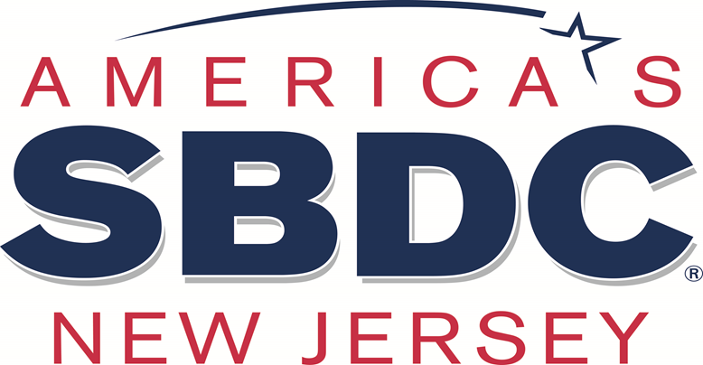



NJ Small Business Development Center

At Rutgers University

419 Cooper Street

Camden, NJ 08102